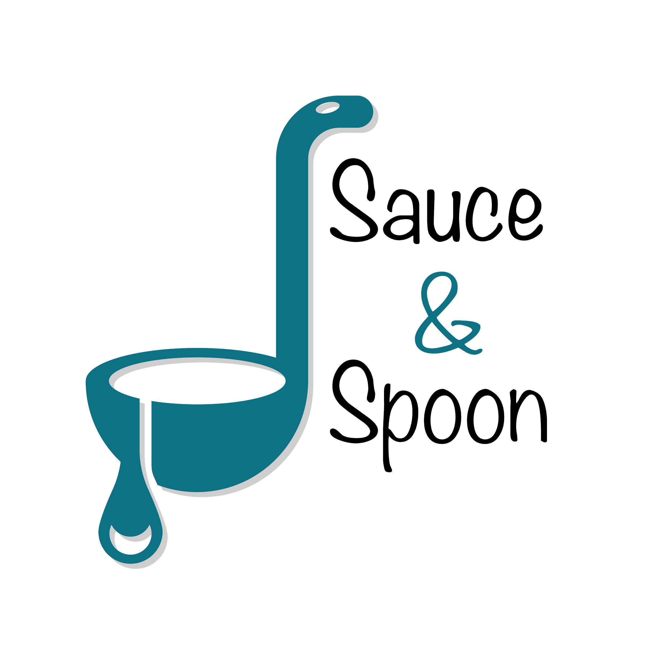

**Project Charter: Tabletop Menu Tablets for Orders**

**DATE: [07-September-2023]**

| **Project Summary** |
| --- |
| Sauce and Spoon's (Restaurant) pilot project aims to introduce tableout menu tablets for efficient customer ordering, facilitating growth and expansion while adhering to a new policy on food waste reduction, ensuring fresh food for customers. |

| **Project Goals** |
| --- |
| Pilot the new system that integrates the new POS software with the existing host software in Second Quarter (Q2) plus by the end of Q2, achieve the following **SMART** goals:   * Improve table service efficiency by installing tablets menu since Q2. * Speed up service and more table turnover rates/reduce guest wait time. * Increase average check out total to $75 by sell more appetizer and beverages   by the end of Q2.   * Increase daily guest count by 10% by the end of Q2. * Decrease average turn time by approx. 30 min by the end of Q2. * Increase appetizer order overall by 15%. (Downtown 20% and North 10%) * Reduce employee turnover rate and increase employee satisfaction. |

| **Deliverables** |
| --- |
| * Develop point-of-sale or POS software to promote certain items, manage prices, track orders, and generate the check at the end of a meal. * Integrate the new POS software with the existing host software that tracks table usage and wait lists, to offer clear data points for metrics tracking to ensure the restaurant’s success. * Implement tabletop menu tablets on Downtown and North locations. * Create training material and train staff on a new tablet ordering system. * Tablet package with the menu item add-on feature and coupons. * Tablet software compatible with existing systems. * Update website and menu design. * Partner with 5 new, local, and sustainable vendors each year on a rotating basis. * Use only local vendors (250 miles radius) in all of our operations, and support local. * Business through sourcing and partnership. |

| **Scope and Exclusion** |
| --- |
| **In-Scope:**   * Launch a pilot rollout of tabletop menu tablets at the bar area. * Tablet ordering system rollout. * New website and menu design. * Improve kitchen employee satisfaction metric. * Train staff with a new system. * Only pilot at two of our restaurant locations, Sauce & Spoon North and Sauce & Spoon Downtown.   **Out-of-Scope:**   * The tabletop menu tablets will not be implemented at the other restaurant locations. * Implement a new policy for food waste. * Hire more kitchen staff (Back of House Staff). * The change of send-back policy. * For Physically disabled people (Specifically, Blind Customers), regular order instead of using this new order system. |

| **Benefits & Costs** |
| --- |
| **Benefits:**   * Speed up service. * Integration of new policy (Reduction in Food Waste). * Avoiding Miscommunication between a service provider and a customer. * Increase sales by an estimated percent. * Provide restaurants with clear data points on customer ordering and an   Integrated point-of-sale (POS) system to help guide decision-making in the future.   * Improve employee royalty.   **Costs:**   * Money spent on:   + Training Materials and Fees - $10,000   + Hardware and Software Implementation - $30,000   + Maintenance (IT Fees through EOY) - $5000   + Updated Website and Menu Design Fee - $5000   + Other Customisation Fee’s - $550   + **Total : $50,550** * Time spent on training staff using new software. * For Blind Customers, Voice based software (order system) may cost extra. |

| **Appendix** |
| --- |
| * Drafting the project charter ([Sauce & Spoon Menu Tablets Project Proposal](https://www.coursera.org/learn/applying-project-management/resources/hHiP1), [Sauce & Spoon: Company OKRs](https://www.coursera.org/learn/applying-project-management/resources/fp3OX), [Meeting note: Clarifying Project Goals](https://www.coursera.org/learn/applying-project-management/resources/6jcbL)) * Alex and Gilly agree on the following three goals: Cut food waste by 25%, Reduce table turn time by 30 minutes, Increase daily guest counts by 10%. ([Email: Sales Goal Details](https://www.coursera.org/learn/applying-project-management/resources/FDWOh)) * Alex wanted a more aggressive increase, however Gilly pointed out that her location doesn’t generally experience much of an impact from app sales. So, I’m proposing a 15% overall average increase, with the North location targeted for a 10% increase and the Downtown location targeted for a 20% increase. ([Email: Sales Goal Details](https://www.coursera.org/learn/applying-project-management/resources/FDWOh)) * Gilly said that wait time also depended on how busy the restaurant was. So wait time is removed from our goal. ([Video Chat: Decrease Guest Wait Time](https://www.coursera.org/learn/applying-project-management/resources/eQdmF)) * Deanna's expected average check goal is important. Deanna also concerned payroll and resourcing. So an average check goal is added to the project goal, and adding ‘monitor the payroll and bandwidth of the BOH’ and ‘open up two-part time line cook roles. ([Email: Project Goals](https://www.coursera.org/learn/applying-project-management/resources/Ql8xv)) * Proposed by Gilly, the change of send-back policy is excluded from the scope of this project. ([Meeting: Scope Details](https://www.coursera.org/learn/applying-project-management/resources/oGvLo)) * Identify the money cost and are added in the benefit and cost section. ([Document: Tablet Cost](https://www.coursera.org/learn/applying-project-management/resources/DiTdO)) |